Computer Assignment 5 - Hierarchical Clustering

$\text{Machine Learning, Spring 2020}$

Rui Li

# If necessary, make sure to install.packages("gplots") so that the following command works:  
library(gplots)

##   
## Attaching package: 'gplots'

## The following object is masked from 'package:stats':  
##   
## lowess

#Load the data  
trial.sample = read.table("TCGA_sample.txt", header = TRUE)  
#Store the subtypes of tissue and the gene expression data  
Subtypes = trial.sample[,1]  
Gene.Expression = as.matrix(trial.sample[,2:2001])

# Hierarchical Clustering - TCGA Data

Because $k$-means works by finding the physical mean point in space for each cluster, we give it the raw data as input. However, our next two methods do not need the raw data, only the distances between points. As we are clustering the patients, we first must calculate pairwise distances between the patients. The *dist(X, method)* function can be used to calculate the pairwise distances between the rows of a matrix $X$ using the specified *method* as a distance metric. Calculate the average Euclidean and average absolute pairwise distances between patients (a $217×217$ matrix) using the following code:

dist.euclid = dist(Gene.Expression, method = "euclidean")  
dist.abs = dist(Gene.Expression, method = "manhattan") #absolute distance

There are many ways in **R** to perform hierarchical clustering. We will use the most basic version, *hclust()*. Run hierarchical clustering on the patients using the Euclidean and absolute distance matrix using the following code. Using *plot()* on the output object automatically draws the dendrogram. For a quick look at how well these clusters match the true cancer subtypes, we use *labels = types*.

types = rep(0,217)  
types[which(Subtypes == "Basal")] = "B"  
types[which(Subtypes == "Normal")] = "N"  
  
#Euclidean distance  
hc.euclid = hclust(dist.euclid)  
plot(hc.euclid, labels = types, cex = 0.5)

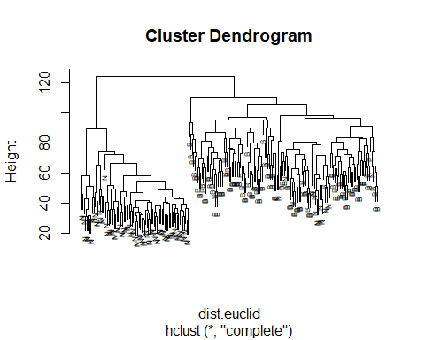

#Absolute distance  
hc.abs = hclust(dist.abs)  
plot(hc.abs, labels = types, cex = 0.6)

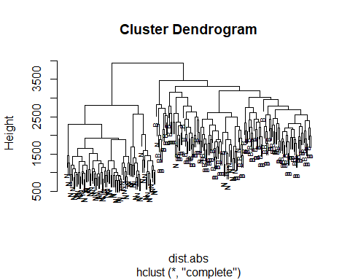

Note that the dendrograms are generated based on pairwise distances between the patients. We can visualize this by using *heatmap( )* to plot the original data according to the hierarchical cluster ordering.

heatmap(Gene.Expression, Rowv = as.dendrogram(hc.euclid), Colv = NA,   
 main = "Heatmap of TCGA data based on Euclidean Distance",   
 xlab = "Genes", ylab = "Patients", col = redgreen(50))

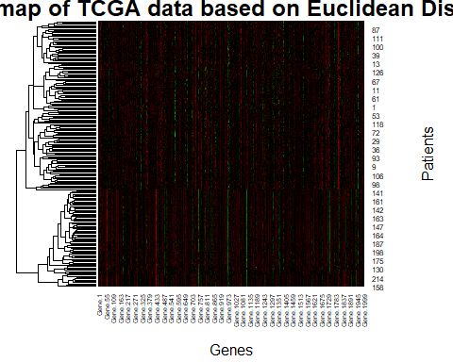

## Questions

1. Comment on the differences between the two dendrograms. Does one distance appear to cluster differently than the other? Which do you prefer?

Both dendrograms have generally cluster the two subtypes into the two groups. However, the group on the right has mixed some 'N' type cases. For 'Euclidean Distance', those 'N' cases belong to the sub groups close to each other, while the 'Absolute Distance' has some cases belong to sub groups far away from each other. Therefore, I prefer the 'Euclidean Distance'.

1. What agglomeration (linkage) method was used for the above clusterings? (Hint: check the manual page)

According to the manual page, the default method of 'hclust' is complete.

1. Perform the euclidean distance clustering with single and average linkage. Print out their respective dendrograms and comment on how they differ. Do they differ at all from the above euclidean distance clustering?

#Euclidean distance with 'single' linkage  
hc.euclid.s = hclust(dist.euclid, method = "single")  
plot(hc.euclid.s, labels = types, cex = 0.5, main = "Euclidean distance with 'single' linkage")

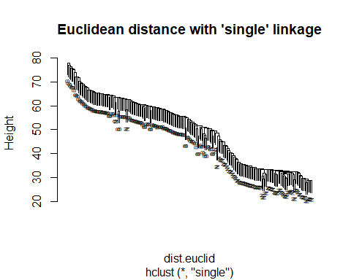

#Euclidean distance with 'average' linkage  
hc.euclid.a = hclust(dist.euclid, method = "average")  
plot(hc.euclid.a, labels = types, cex = 0.5, main = "Euclidean distance with 'average' linkage")

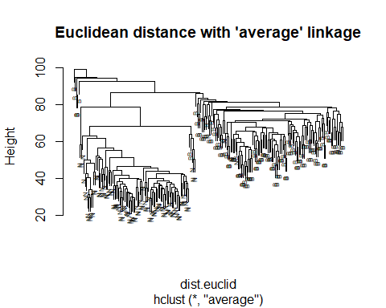

The 'single' linkage forms as a line, with single sample in each group, while the 'average' linkage scatters the patients into different groups. The 'single' looks totally different from the above euclidean distance clustering, and the plot shows groups in a linear way. The 'average' generally looks the same as the above euclidean distance clustering, and largely sperates two sub types in to two groups.

1. Hierarchical clustering does not automatically make a certain number of clusters from the data - this depends on where you “cut” the dendrogram. Draw a line on your plots showing where you cut the dendrogram. How closely do the subtypes appear to cluster in these two groups?

#Euclidean distance with 'single' linkage  
plot(hc.euclid.s, labels = types, cex = 0.5, main = "Euclidean distance with 'single' linkage")  
abline(v=130,col='red')

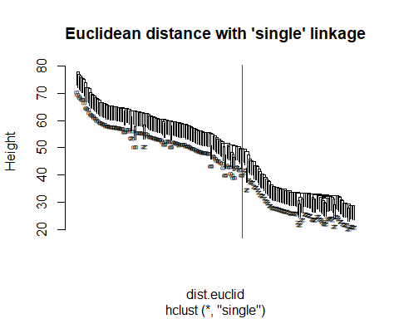

#Euclidean distance with 'average' linkage  
plot(hc.euclid.a, labels = types, cex = 0.5, main = "Euclidean distance with 'average' linkage")  
abline(v=99,col='red')

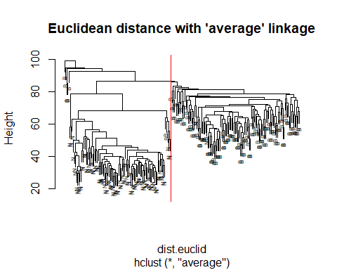

For the 'single', the subtypes show similarly as the groups in clustering. However, for the 'average', two subtypes have some sample mixed into the other group of clustering.

1. The function *cutree(tree, … )* will produce clusters based on a certain cut of the dendrogram *tree*. We can specify either height (*h*) or number of clusters (*k*). Use *cutree()* on the Euclidean distance clustering to assign clusters. What percentage of the each cluster is Normal and Basal? (Hint: Use *?cutree* to figure out exactly how to use this function.)

ct.n <- cutree(hc.euclid,k=2)  
plot(hc.euclid, labels = types, cex=0.5, main = "Euclidean Distance Clustering")  
rect.hclust(hc.euclid, 2)

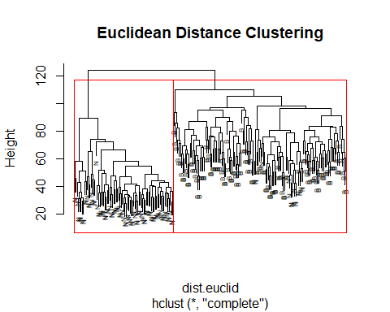

library(plyr)  
#Count Cluster 1 and 2  
cluster_1 = count(ct.n)[1,2]  
cluster_2 = count(ct.n)[2,2]  
  
#Count 'Normal' and 'Basal'  
cluster_1_Basal = count(ct.n==1&Subtypes=='Basal')[2,2]  
count(ct.n==2&Subtypes=='Basal')[2,2]# The value is NA.

## [1] NA

cluster_2_Basal = 0  
cluster_1_Normal = count(ct.n==1&Subtypes=='Normal')[2,2]  
cluster_2_Normal = count(ct.n==2&Subtypes=='Normal')[2,2]  
  
print(paste("Cluster 1 contains 'Normal': ", cluster_1_Normal/cluster_1))

## [1] "Cluster 1 contains 'Normal': 0.115942028985507"

print(paste("Cluster 1 contains 'Basal': ", cluster_1_Basal/cluster_1))

## [1] "Cluster 1 contains 'Basal': 0.884057971014493"

print(paste("Cluster 2 contains 'Normal': ", cluster_2_Normal/cluster_2))

## [1] "Cluster 2 contains 'Normal': 1"

print(paste("Cluster 2 contains 'Basal': ", cluster_2_Basal/cluster_2))

## [1] "Cluster 2 contains 'Basal': 0"

1. Suppose that you read a scientific paper where the authors use hierarchical clustering on a data set and show a figure similar to what you just created. What kinds of questions might you be inclined to ask the authors regarding their clustering? Does the flexibility of the clustering (the choice of distance, the choice of linkage, etc.) make you more or less confident in the authors’ clustering?

Since different choice of distance calculation will affect the quality of clustering. I will ask how and why he choose such a way of distance. Also, different choice of linkage will have different result. I will ask how he know which choice is more appropriate to the data, and how he choose it.

# Hierarchical Clustering - Cereals

Now let’s practice Hierarchical Clustering (HC) with a different data set. The cereal data (named cereals.csv) contains cereal brands, manufacturers (also a variable called group, which is the same info, but group is numeric and manufacturer is categorical), and nutrition information (calories, protein, fat, sodium, fiber, carbs, sugar, potassium) per serving. Do a brief analysis of the data.

library(readr)  
cereals <- read_csv("cereals.csv")

## Warning: Missing column names filled in: 'X1' [1]

## Parsed with column specification:  
## cols(  
## X1 = col_double(),  
## brand = col_character(),  
## manufacturer = col_character(),  
## calories = col_double(),  
## protein = col_double(),  
## fat = col_double(),  
## sodium = col_double(),  
## fiber = col_double(),  
## carbs = col_double(),  
## sugar = col_double(),  
## potassium = col_double(),  
## group = col_double()  
## )

summary(cereals)

## X1 brand manufacturer calories   
## Min. : 1.0 Length:43 Length:43 Min. : 50.0   
## 1st Qu.:11.5 Class :character Class :character 1st Qu.:100.0   
## Median :22.0 Mode :character Mode :character Median :110.0   
## Mean :22.0 Mean :107.9   
## 3rd Qu.:32.5 3rd Qu.:110.0   
## Max. :43.0 Max. :160.0   
## protein fat sodium fiber   
## Min. :1.000 Min. :0.0000 Min. : 0.0 Min. :0.000   
## 1st Qu.:2.000 1st Qu.:0.0000 1st Qu.:145.0 1st Qu.:0.500   
## Median :2.000 Median :1.0000 Median :190.0 Median :1.000   
## Mean :2.465 Mean :0.9767 Mean :180.5 Mean :1.714   
## 3rd Qu.:3.000 3rd Qu.:1.5000 3rd Qu.:220.0 3rd Qu.:2.850   
## Max. :6.000 Max. :3.0000 Max. :320.0 Max. :9.000   
## carbs sugar potassium group   
## Min. : 1.00 Min. : 0.000 Min. : 15.00 Min. :1.000   
## 1st Qu.:12.00 1st Qu.: 3.000 1st Qu.: 37.50 1st Qu.:1.000   
## Median :14.00 Median : 8.000 Median : 60.00 Median :2.000   
## Mean :14.26 Mean : 7.605 Mean : 84.42 Mean :1.744   
## 3rd Qu.:17.00 3rd Qu.:12.000 3rd Qu.:110.00 3rd Qu.:2.000   
## Max. :22.00 Max. :15.000 Max. :320.00 Max. :3.000

Perform HC using euclidean distance and average linkage and all variables *except* brand, manufacturer, and group. Make sure to plot the dendogram, and label each leaf by brand. Do you see any interesting clusterings based on cereal brands? Use the cutree() function and experiment with *h* and *k* to see if you can find any meaningful clusters.

#Store the subtypes of brand and the cereals data  
subtypes_brand = cereals[,2]  
cereal_data = as.matrix(cereals[,-c(1:3,12)])  
  
#Calculate the euclidean distance  
dist.euclid.cereal = dist(cereal_data, method = "euclidean")  
  
#Plot the dendrogram  
hc.cereal=hclust(dist.euclid.cereal, method="average")  
plot(hc.cereal, labels=cereals$brand, cex=0.5, main = "Brand Euclidean Distance Clustering")  
  
#Cutree()  
ct.cereal <- cutree(hc.cereal,k=7)  
rect.hclust(hc.cereal, 7)

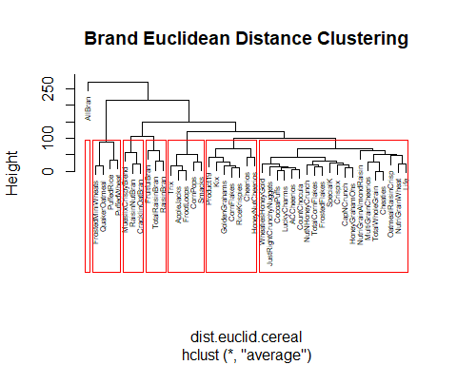

There are some clustering based on the brand, but it is not obvious, each brand belongs to a sub group.

Now, change the labels on the dendrogram to manufacturer and see if you can find a meaningful *k* and *h*. Comment on your findings.

plot(hc.cereal, labels=cereals$manufacturer, cex=0.5, main = "Manufacturer Euclidean Distance Clustering")  
  
#Cutree()  
ct.cereal <- cutree(hc.cereal,k=5)  
rect.hclust(hc.cereal, 5)

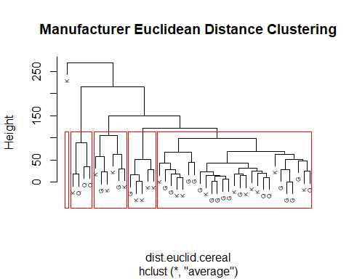

Generally, there is a meaningful k=5, largely separates subtypes of G,K,Q.

Using the *k* you decided upon using HC with manufacturer as your labels, run a k-means clustering on the cereal data. Compare to the clustering you found using HC. This comparison can be done a number of ways: you can project onto the first two PCs and plot, you can print out the cluster labels from each method and calculate how often the matched/didn’t match, etc.

Note: This question is intentionally open ended. Use code from previous assignments, and suggestions online, to provide a FULL hierarchical clustering analysis of this data.

#PCA on the dataset cereals  
pc.cereal = prcomp(cereal_data)  
  
#Plot the projections in the first two PC dimensions.  
cereal.pred = predict(pc.cereal, cereal_data)  
plot(cereal.pred[,1:2],col=as.factor(cereals$manufacturer), main = "Plot of First Two PCs; Colored by manufacturer")

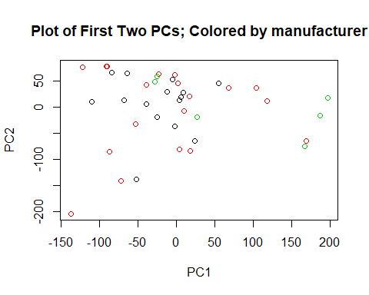

#K=5  
k_5 = kmeans(cereal_data,5,iter.max = 100)  
plot(cereal.pred[,1:2], col=k_5$cluster, main = "Plot of First Two PCs;Colored by Clusters")

